**Lab Report Prospectus**

Title: Twin Cites Energy Cost Map

Notice: Dr. Bryan Runck

Author: Cole Anderson

Date: 2/18/21

**Project Repository:**<none yet>

**Abstract**

<preliminary>

The 1st deliverable is a street dataset with elevation and slope values, used to calculate an energy cost. The 2nd deliverable is a simple web application for visualizing shortest path and slope. This will require a street centerlines dataset and DEM dataset of the Twin Cities study area. In simplest terms, the methods will involve attaching these two datasets and calculating new slope, elevation and cost elements for each street segment, writing a comprehensive shortest path algorithm, and integrating both into a visually accessible web interface. Discussion will focus on comparison to existing product, use in existing mapping applications, and design challenges.

**Problem Statement**

Create an elevation map of the UMN campus that illustrates street terrain and slop. Develop an accessible map interface that allows users to compute street path with lowest energy cost across this terrain, and view street slope attributes.

-Data integration using python ETL

-Intermediate data analysis techniques

-Connections to background reference

-Extensively documented codebooks

-GitHub Repo with documentation

Table 1. Required Elements for Project Problem Statement

|  |  |  |  |  |  |  |
| --- | --- | --- | --- | --- | --- | --- |
| **#** | **Requirement** | **Defined As** | **Spatial Data** | **Attribute Data** | **Dataset** | **Preparation** |
| 1 | Collect Terrain Map | DEM dataset for study area | elevation | Elevation? | [Mn GeoSpatial Commons](https://gisdata.mn.gov/dataset/trans-roads-mndot-tis) |  |
| 2 | Collect Street Map | Street Center Lines | centerlines | Addresses? Coordinates | AADT Data |  |
| 3 | Rectify layers in 3d? | Output 1, 2 combination, street data w/ elevation |  |  |  |  |
| 4 | Create Shortest Path Program | Energy Cost and Djikstra’s Algorithm between lat/long |  |  |  |  |
| 5 | Design GUI | Visual interface | n/a | n/a | n/a |  |

**Input Data**

DEM and Street Data to find slopes/distances

Desired Data Sets

|  |  |  |  |
| --- | --- | --- | --- |
| **#** | **Title** | **Purpose in Analysis** | **Link to Source** |
| 1 | <DEM, Minneapolis> | Raw input for street elevation | [Not](https://gisdata.mn.gov/dataset/trans-roads-mndot-tis) found |
| 2 | <Street Center Lines w/ segments> | Raw input for street locations | [Not](https://gisdata.mn.gov/dataset/trans-roads-mndot-tis) found |
| 3 | <UMN Buildings?> | Possible start/end points | [Not](https://gisdata.mn.gov/dataset/trans-roads-mndot-tis) found |

**Methods**

* Download all data using API scripts
* Inspect and trim elevation and street map
* Join datasets so all street segments have end nodes with an elevation and coordinates

**Next 2 steps dependent on if streets are distorted correctly to new sloped distance by DEM:**

* Create slope attribute from elevation and coordinates
  + Sloped distance = (straight line distance N1, N2)/(cos(β))
  + Slope = -90 to +90 degrees
  + Unless this is created by rectifying to DEM? Would be easier
* Use slope and length to calculate energy cost for each street segment
  + Energy cost = (3D distance)( |Slope| ), assuming up and down require same energy
* Create an algorithm that can calculate least costly distance, using Arcpy and Python
  + <https://bradfieldcs.com/algos/graphs/dijkstras-algorithm/>
  + Djikstra’s will not work with negative cost
* Design a basic web API that displays slope in pop-ups and in color gradient

Figure 1. Data flow diagram.

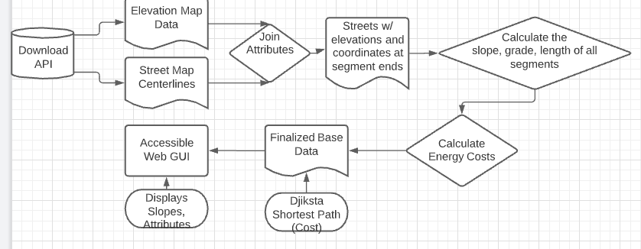

**Results**

* Hoping for a Web App GUI as final result (similar in concept to accessmap) . May have to decrease scope to ArcPro layer or ArcOnline map based on deadlines

Figure 2. Generalized Web App Appearance

Table 2. Required Final Attributes for streets

|  |  |  |  |  |  |  |  |
| --- | --- | --- | --- | --- | --- | --- | --- |
| STREET | SEGMENT | EVL_P1 | ELV_P2 | DISTANCE | S. DISTANCE  (?????) | SLOPE | ENERGY |
| Danielson | Smith to 2nd | 30 m | 35 m | 5 m | 25 sqrt 2 | 45 degrees | 1591 U |

**Results Verification**

The best way to test the results would be to travel along the created paths on campus.

Uncertain how to test for actual least energy path besides test pedestrian exhaustion levels.

User should be able to select street and easily determine slope/location.

For now, a running app would be enough proof of success.

**Discussion and Conclusion**

Compare to ACCESS-MAP

Discussion of usability and integration

Challenges

Questions for Bryan:

* Slope differs based on start/end points. As the energy cost is based on the absolute slope, a + or – relative to horizon does not matter for that, but it does for slope attribute
* Will I need to calculate new sloped distances or will attaching streets to DEM do that?

**References**

*Use a common format*

**Self-score**

*Fill out this rubric for yourself and include it in your lab report. The same rubric will be used to generate a grade in proportion to the points assigned in the syllabus to the assignment.*

|  |  |  |  |
| --- | --- | --- | --- |
| **Category** | **Description** | **Points Possible** | **Score** |
| **Structural Elements** | All elements of a lab report are included **(2 points each)**:  Title, Notice: Dr. Bryan Runck, Author, Project Repository, Date, Abstract, Problem Statement, Input Data w/ tables, Methods w/ Data, Flow Diagrams, Results, Results Verification, Discussion and Conclusion, References in common format, Self-score | 28 | **27** |
| **Clarity of Content** | Each element above is executed at a professional level so that someone can understand the goal, data, methods, results, and their validity and implications in a 5 minute reading at a cursory-level, and in a 30 minute meeting at a deep level **(12 points)**. There is a clear connection from data to results to discussion and conclusion **(12 points)**. | 24 | **23** |
| **Reproducibility** | Results are completely reproducible by someone with basic GIS training. There is no ambiguity in data flow or rationale for data operations. Every step is documented and justified. | 28 | **27** |
| **Verification** | Results are correct in that they have been verified in comparison to some standard. The standard is clearly stated **(10 points)**, the method of comparison is clearly stated **(5 points)**, and the result of verification is clearly stated **(5 points)**. | 20 | **19** |
|  |  | 100 | **96** |